** DEPARTMENT OF COMPUTER SCIENCE & ENGINEERING**

**SAI VIDYA INSTITUTE OF TECHNOLOGY**

(Affiliated to VTU, Belagavi, Approved by AICTE, New Delhi and Govt. of Karnataka)

Rajanukunte,Bengaluru-560064

Tel: 080-2846 8196, Fax: 2846 8193 / 98, Web: saividya.ac.in

**Report on Data Communication**

**Topic Name: Point To Point Protocol**

**Name : Deepak Jaiswal**

**Usn: 1VA18CS010**

**Faculty Name: Archana R A**

**Presented on: 08/06/2020**

**WHAT IS POINT TO POINT PROTOCOL:**

Point - to - Point Protocol (PPP) is a communication protocol of the data link layer that is used to transmit multiprotocol data between two **directly connected** (point-to-point) computers. It is a byte - oriented protocol that is widely used in broadband communications having heavy loads and high speeds. Since it is a data link layer protocol, data is transmitted in frames.

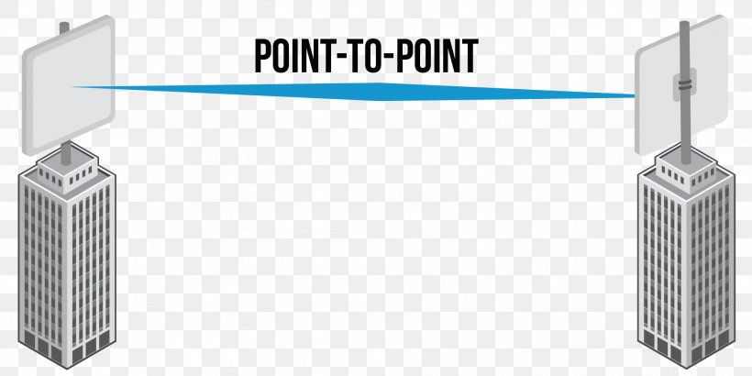

**PPP provides several services:**

1. PPP defines the format of the frame to be exchanged between devices.

2. PPP defines how two devices can negotiate the establishment of link and the exchange of data.

3. PPP defines how network layer data are encapsulated in the data link frame.

4. PPP defines how two devices can authenticate each other.

5. PPP provides connections over multiple links.

**Frame Format:**

PPP uses a character-oriented (or byte-oriented) frame. Below figure shows the format of a PPP frame

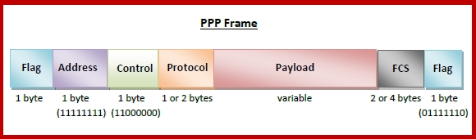

Figure: Frame Formatting

**The description of each field follows:**

**•** **Flag**: The flag field identifies the boundaries of PPP frame i.e. each frame begins and ends with flag field of 1-byte of length with the bit pattern 01111110.

**• Address**: The address field in this protocol is a constant value and set to 11111111 (broadcast address).

**• Control**: This field is set to the constant value 11000000.This indicates frame does not contain sequence numbers.

**• Protocol**: The protocol field defines what is being carried in the data field: either user data or other information. The protocol field is 1 or 2 bytes long.

**• Payload field**: This field contains the actual data to transmit. It carries either the user data or other information. The length of this field is variable.

• **FCS**: The frame check sequence (FCS) is simply a 2-byte or 4-byte standard CRC code. It checks length of all fields in frame.

**Transition States:**

The transition state is used to indicate the phases through which PPP connection passes. Below figure shows PPP transition states:

The description of each field follows:

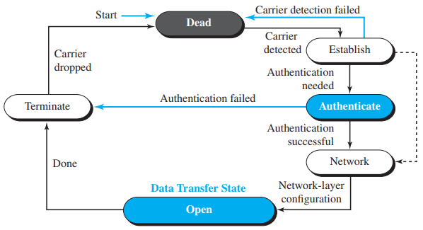

Figure: Transition states

• Dead: In the dead phase the link is not being used. There is no active carrier (at the physical layer) and the line is quiet.

• Establish: When one of the nodes starts the communication, the connection goes into this phase. In this phase, options are negotiated between the two parties. If the negotiation is successful, the system goes to the authentication phase (if authentication is required) or directly to the networking phase.

• Authenticate: The authentication phase is optional; the two nodes may decide, during the establishment phase, not to skip this phase. However, if they decide to proceed with authentication, they send several authentication packets. If the result is successful, the connection goes to the networking phase; otherwise, it goes to the termination phase.

• Network: In the network phase, negotiation for the network layer protocols takes place. PPP specifies that two nodes establish a network layer agreement before data at the network layer can be exchanged. The reason is that PPP supports multiple protocols at the network layer. If a node is running multiple protocols simultaneously at the network layer, the receiving node needs to know which protocol will receive the data.

• Open: In the open phase, data transfer takes place. When a connection reaches this phase, the exchange of data packets can be started. The connection remains in this phase until one of the endpoints wants to terminate the connection.

• Terminate: In the termination phase the connection is terminated. Several packets are exchanged between the two ends for house cleaning and closing the link.